Logging using SLF4J
Exercise 1: Logging Error Messages and Warning Levels Task: Write a Java application that demonstrates logging error messages and warning levels using SLF4J.
OUTPUT:

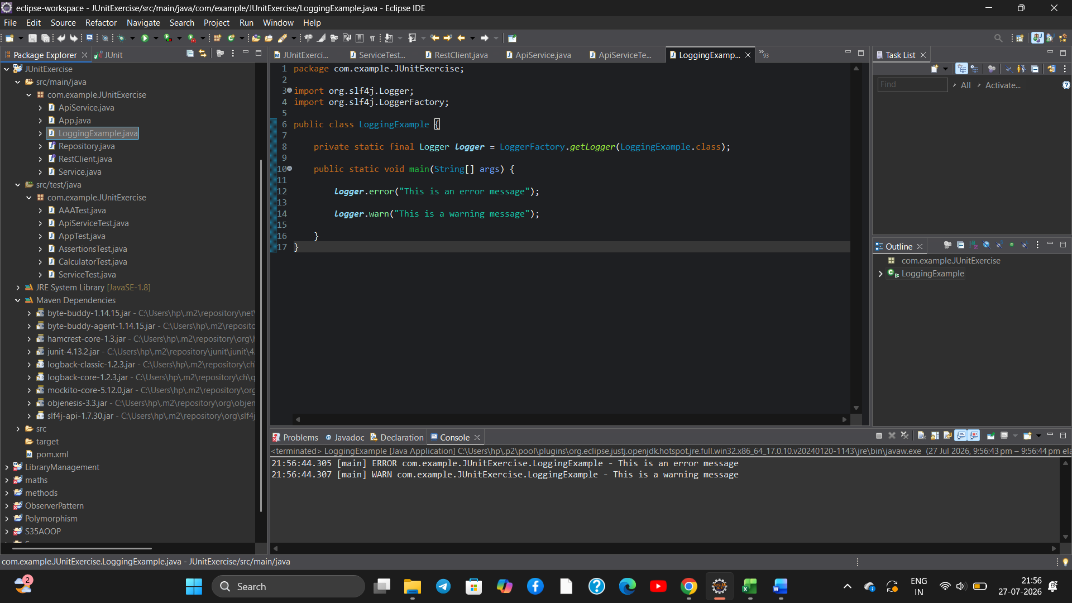
Result:
The Java application successfully demonstrated logging of error and warning messages using the SLF4J API with the Logback framework.

